**October 3rd, 2024**

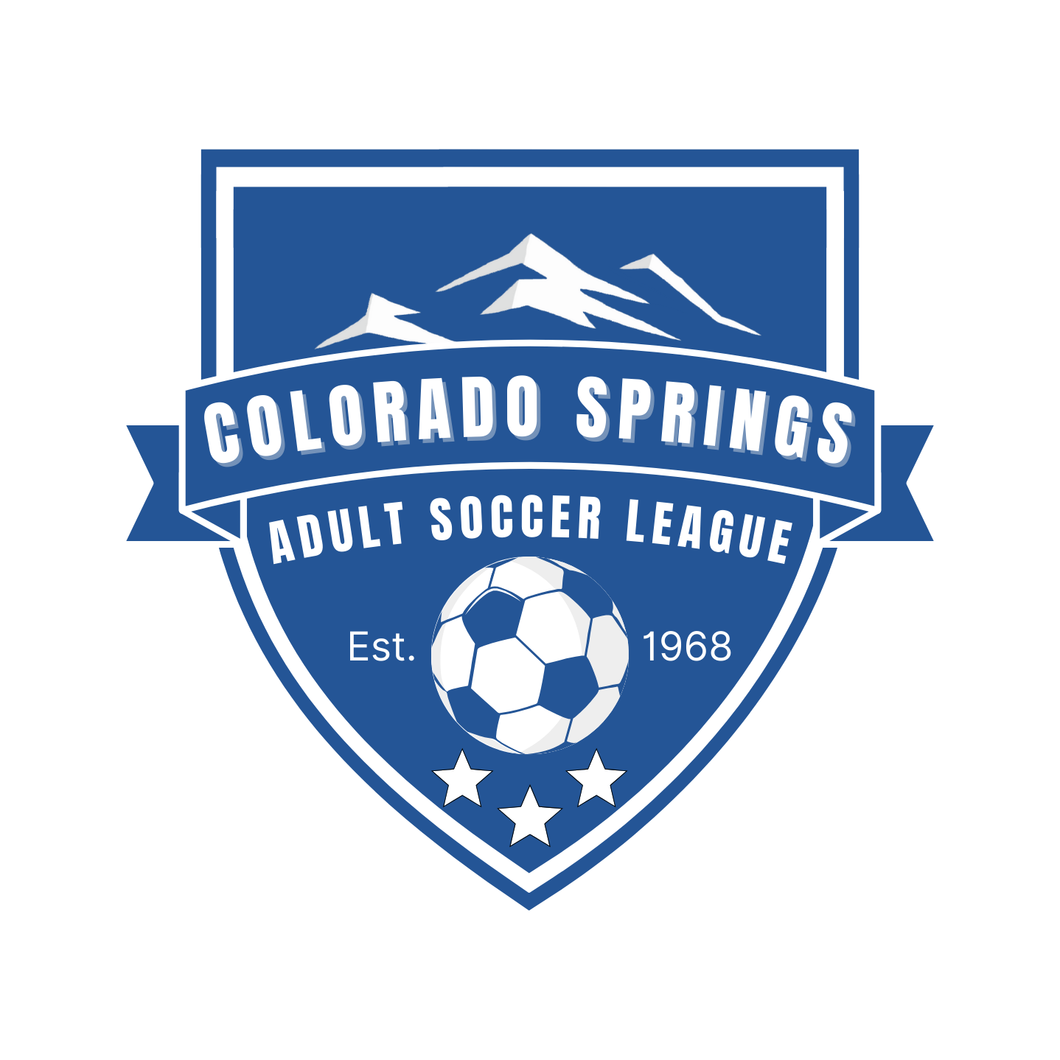

**6:30pm –Virtual (Zoom)**

**Colorado Springs Adult Soccer League**

[**www.cosasl.com**](http://www.cosasl.com)

**PO Box 2021**

**Monument, CO 80132**

**Board of Director’s Agenda**

**Meeting called to order 6:35pm**

1. **Current Board Members:** Jason Hann – President, Courtney McLeod – Secretary, Mary Collins – Director, Nick Borusiewicz – Director
   1. Arrived late: Brian Slivka - Vice President, Katie Anders– Treasurer
   2. Not in attendance: Greg Dingrando – Director, Amy Dowling – Director, Julian Drummond – Director,
2. **Approval of Minutes of September 5th meeting minutes. Jason** called for any edits or changes, none proposed. Jason motioned to approve meeting minutes, Nick seconded, all in favor.
3. **Treasurer’s Report:** Katie present existing balances:
   1. Checking - $47,284.53
   2. Savings - $44,544
   3. Status of Fall 24’ registration and fees:
      1. Referees paid weekly
      2. Garry Berry fields are paid for
      3. We expect to be in the black for this season
      4. Jason motions for Springs United to keep full amount of fundraiser amount from MOD Pizza, versus the 80% / 20% split originally agreed upon; Nick seconds, all in favor. Balance to go toward Springs United registration: $129.43
4. **Fall current status:** Fields, schedule, refs.
   1. Teams status – Positive feedback overall, referee specific feedback has been very positive.
5. **Fields update:**
   1. Garry Berry fields paid for.
6. **Referees & Disciplinary Overview:**
   1. Suggestion regarding yellow card disputes; idea is driven from a conversation had over the past weekend.
      1. Board consensus remains that yellow cards are not disputable, ONLY red cards are disputable. Board to ensure
7. **New Business** –
   1. Marketing Package:
      1. Jason forwarded an email regarding marketing materials. Board member thoughts:
         1. Must Haves: Banner for Pride complex (Jason, Mary to connect with Andy at Pride to coordinate this), Nick and Jason to hopefully pull favors for Soccerhaus banners at no charge, still hopeful to push a better relationship with Let’s Play and establish presence there.
      2. COSASL Sponsorship (league level) conversations: VooDoo Brewing, UC Health, Red Leg Brewing; other opportunities welcomed
   2. League Incident:
      1. A situation occurred on the field which resulted in a player who received multiple injuries. No cards were issued on the field. The board has reviewed video and votes by majority to retroactively award the offending player a Yellow Card.
   3. Representation:
      1. Mary resurfaces conversations surrounding Amy Speed (as Free Agent Manager) and Dan Ferguson’s (open to stepping up where needed) involvement with the league. Jason to connect with Amy and Mary to connect with Dan.
8. **Old Business**
   1. Hummel possibility through Slivka? Offer discount to league, and Brian to see if Hummel will donate game balls each season.
   2. Need to get Soccer Haus trophy case completed and installed.

**Next meeting – Nov. 7th at TBD**

**Meeting Adjourn – Jason called for meeting adjourn at 7:30 PM, seconded by Brian, all in favor.**